**Assignment on String functions**

1. Create first as string
2. Create middle as string
3. Create last as string
4. Combine first, middle and last in name string
5. Display First character of name string
6. Display last character of name string by two methods (+ve and –ve indexing)
7. Display First three characters of name string
8. Display 3rd to 6th character of the string name
9. Display last three characters of the string name by using negative indexing
10. Display length of name string
11. Display type of name string
12. Display id of name var
13. Display name string in small case
14. Display name string in upper case
15. Display name string in capital or proper or title case
16. Repeat last string 5 times and store into new variable
17. Find length of new variable
18. Combine name and new into name1 var, Display name1
19. Replace last string word with abc in name1 var
20. Print index number of any character & print its index value
21. Display occurrence of k character in name1
22. Split name string & display each splited value by List method
23. Split name string by assigning three var & print each varaible
24. Create a string with leading blank spaces and trailing blank spaces
25. Remove leading and trailing blank spaces of the string & print string (hint strip function)
26. Check whether name string is in upper case or not ( hint isupper)
27. Check whether name string is in lower case or not ( hint islower)
28. Check whether name string is in proper case or not ( hint istitle)
29. Join hello string to each character of last string ( hint join)
30. Display help of join function of string (hint help(str.capitalize))
31. Display All methods which can be used with string variable ( Hint on python prompt dir(name))

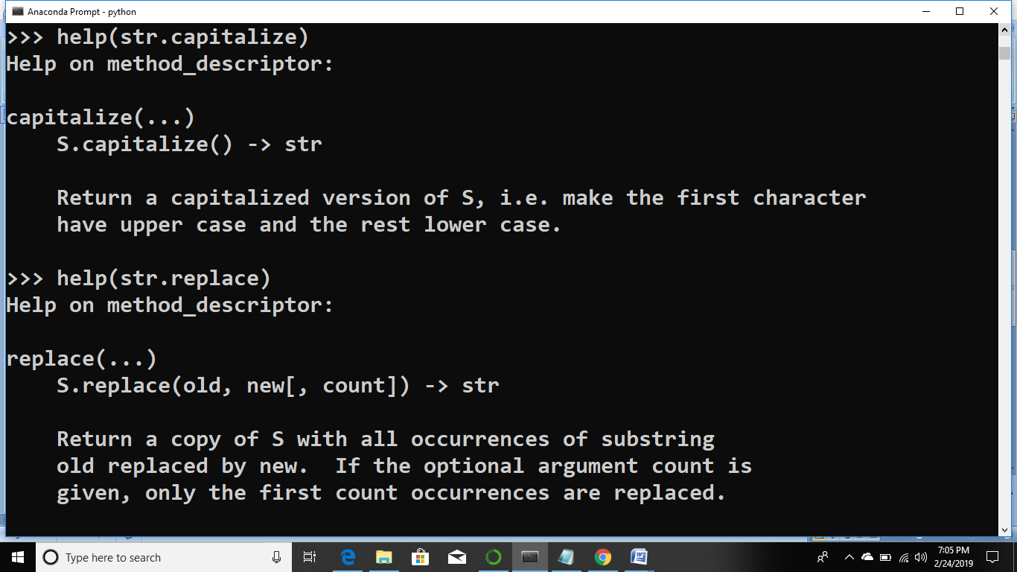

Strip function removes blank spaces

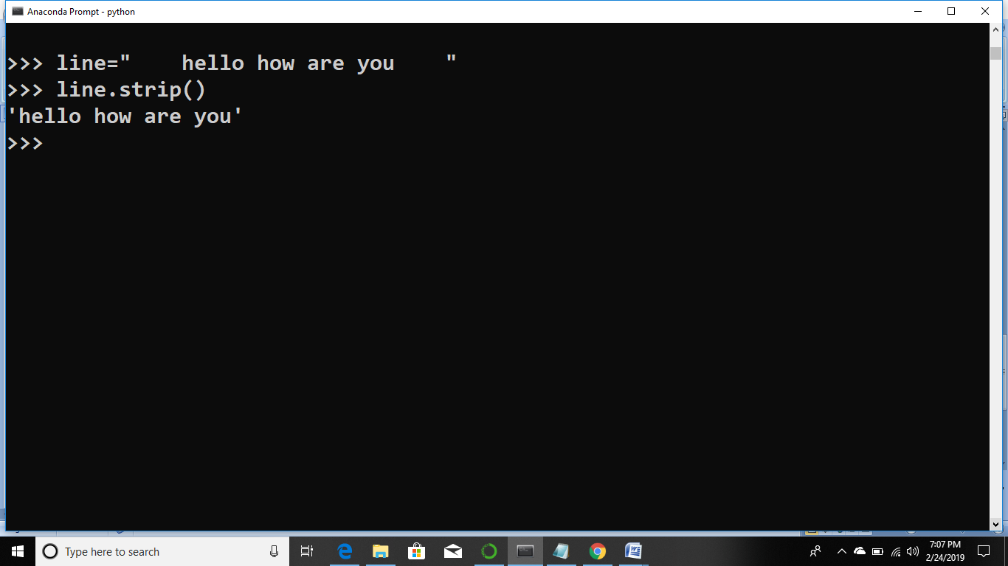

replace

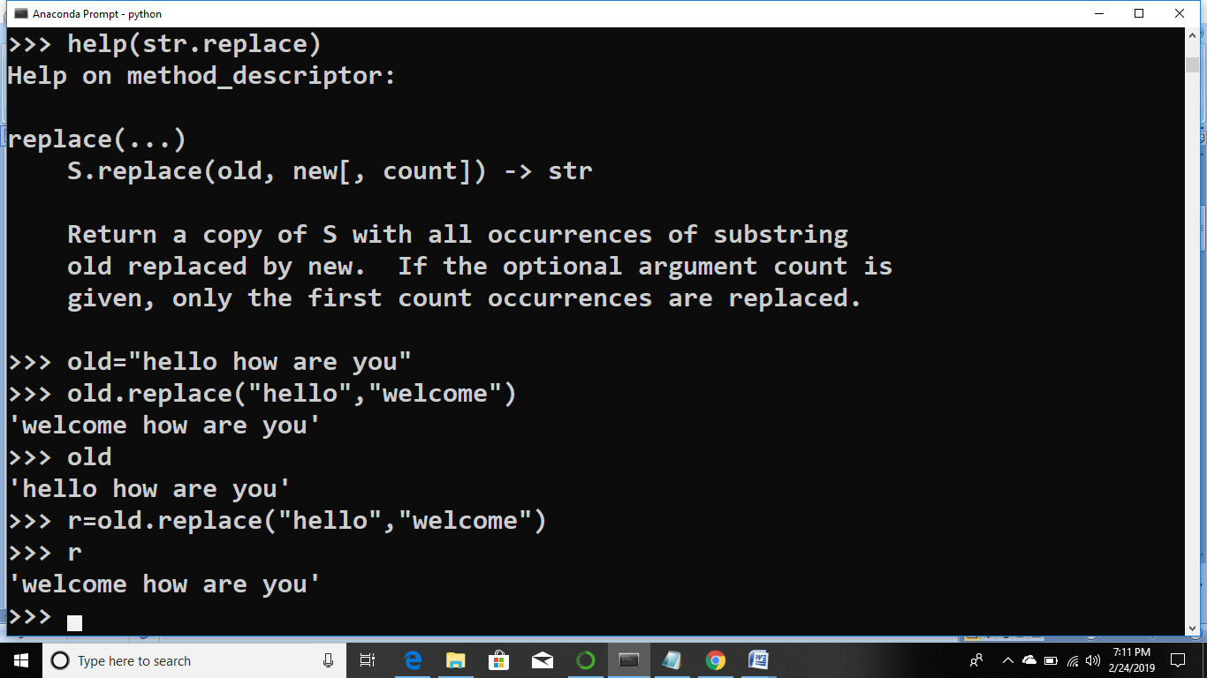

Isupper & islower

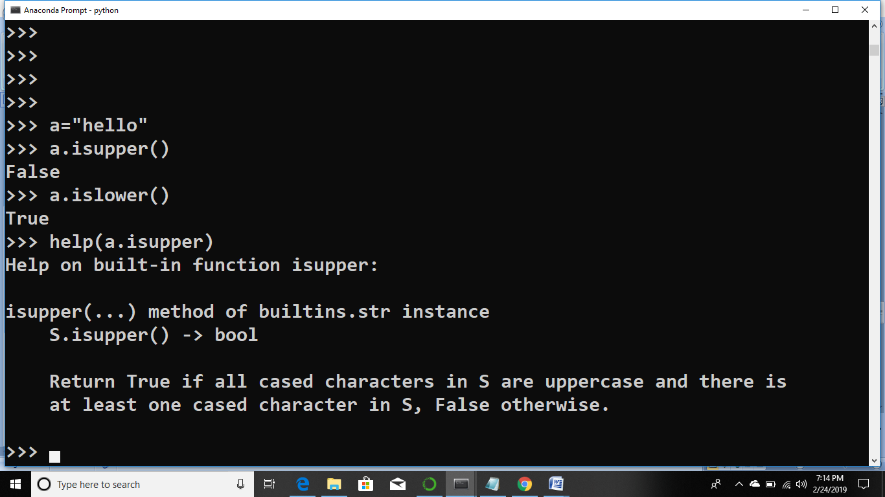

find

>>> address="mumbai@uct.ac.in sat 2019"

>>> atpos=address.find("@")

>>> print(atpos)

6

>>> sppos=address.find(' ',atpos)

>>> print(sppos)

16

>>> host=address[atpos+1:sppos]

>>> print(host)

uct.ac.in

>>>

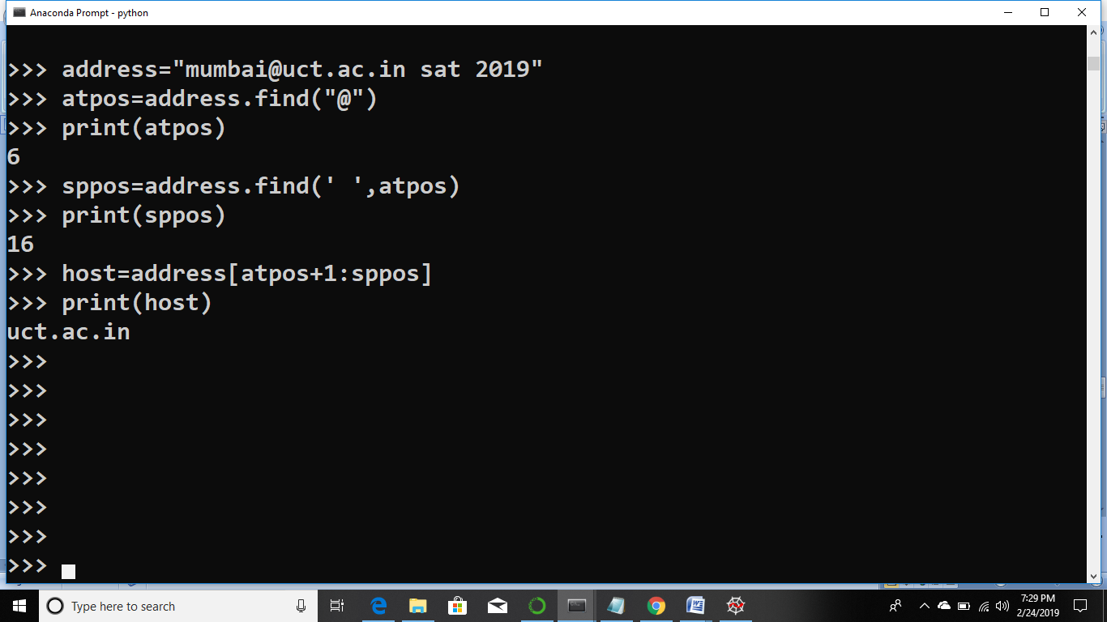

Capitalize

